# Introduction (Automation)

Automation can be defined as the process of following a sequence of operations and instructions preconfigured with little or no human labor, using devices that perform and control the manufacturing processes. In a nutshell, automation is achieved through the smart use of a variety of electronic devices available, such as sensors, actuators and other equipment that are capable of observing the manufacturing process (input), then make decisions and changes based on the situation, and controlling all aspects of the operation. Another way of describing automation is by converting a manual process into an automated or mechanized process.

Modern automated processes are usually controlled by computer programs, with inputs from sensors and actuators as outputs, the system can monitor progress and control the sequences of events until the process is complete. The computer can be programmed to complete the task using the most efficient and accurate way possible.

Automation is an evolutionary process which takes time to configure and apply into a process. Most manual, direct-labor work which are repetitive and don’t require much critical thinking or decision making, i.e. the human factor can mostly be converted into an automated process, which is easier, safer and produces better results compared to manual labor. This is because computer programs work consistently as programmed in every sequence in the process, which humans have a tough time replicating.

By replacing manual labor in these kinds of tasks, workers can be trained for more skillful accomplishments that are required for better jobs in the future.

# Advantages and Reasons of Automation

* Increased Productivity
  + Higher production output with minimal labor input. Productivity is the most important factor in determining the standard of living of a country. Overall income scales with the overall manufacturing output.
* Minimization of human fatigue
  + Humans get tired after hours of work, which will affect productivity and the quality of the products. Humans will also get bored if they continuously work on repetitive tasks which offers no growth in experience and technical skills. Machines can help solve these problems.
* Floor area reduced
  + Less production area needed if manual labor is reduced.
* Better working conditions for workers
  + Machines can accomplish tasks that are difficult and pose safety hazards to workers. This allows workers to focus on jobs in better working conditions.
* Effective control over production process
  + Machines and computer programs can be optimized and upgraded over time to increase performance and quality of product
* Improvement in quality of products
  + Machines run as programmed, thus they can handle difficult jobs more precisely and achieve better quality products with less defects compared to manual labor.
* Accidents reduced and increased safety for workers
  + Workers are not required to be directly involved in the production. They will instead reprise a more supervisory role. The job scope will involve more on checking on the process and debugging any problems with the automation system, and optimizing the performance of the automation system to maximise efficiency and output. This puts the worker at less risk.
* Reduction in production costs
  + Reduced in production costs means higher net profits, which is the ultimate goal of a company. Lower prices, better quality products and higher production output all results positively for a company’s business.

# Application (Automation)

* Automatic machine tools to process parts
* Automatic assembly machines
* Industrial robots
* Automatic material handling
* Automated storage and retrieval systems
* Automatic inspection systems
* Feedback control systems
* Computer systems for automatically transforming designs into parts
* Computer systems for planning and decision making to support manufacturing.

# Automation strategies

Automation is not the solution to every problem. Thus, strategies and approaches have to be used to determine whether a certain problem does require automation or not.

1. Specialization of operations.
   1. Use special-purpose equipment designed to perform one specific task or operation with maximum efficiency. Improves productivity greatly.
2. Combined operations.
   1. Reduces the number of machines and workstations. Saves material handling effort, waiting time, manufacturing lead time
3. Simultaneous operations
   1. Simultaneously perform different tasks at one workstation
4. Increased flexibility
   1. Use the same equipment for a variety of parts or products. Lower manufacturing lead time and less work-in-progress
5. Improved material handling and storage.
6. On-line inspection
7. Process control and optimization
   1. Control of individual manufacturing processes
8. Plant operations control
   1. Control of manufacturing plants. Manage and coordinate the aggregate operations in the plant more efficiently. Servers and computer networking of high level are involved in this implementation.
9. Computer-integrated manufacturing (CIM).
   1. CIM involves extensive use of computer systems, databases and networks throughout the enterprise to integrate the factory operations and business functions.

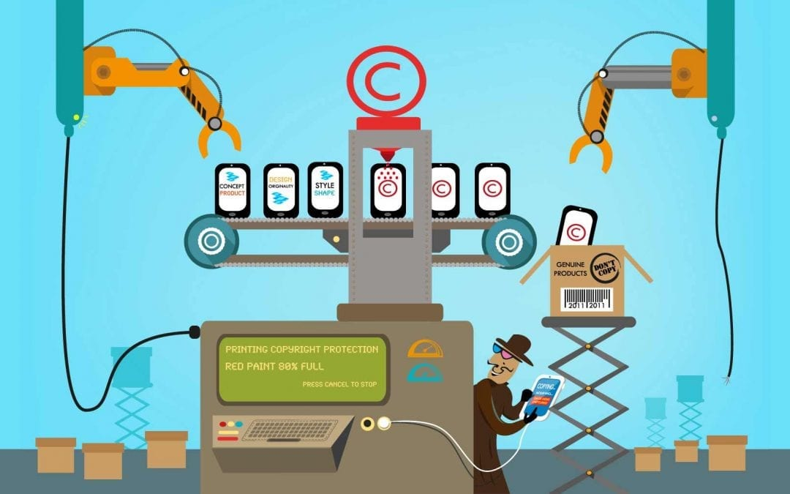

Figure: Automation

# Introduction to robotics

Robotics is the intersection of science, engineering and technology that produces machines and robots which acts as a substitute for human endeavors ( “Built in”, n.d.). Robots are able to perform many different tasks and operations precisely, and require less concern for common safety and comfort elements that human needs. However well robots can replicate and act as a substitute for humans, it takes time and effort to design and program a robot to function properly. Robots also have a limit to what they can do. Therefore, they need to be designed as such that they work for the intended purpose, then they will become a powerful and useful tool.

Industrial robots are advanced automation systems, controlled by a computer through programs configured by humans. They mainly supervise production lines and control manufacturing systems such as machine tools, welders, laser cutting devices and others. These robots are involved in the automation of manufacturing processes in factories. The Japanese categorise industrials into 4 levels:

* Manual manipulators: perform fixed or preset task sequences
* Playbacks: Repeat pre-programmed fixed instructions
* NC robot: carry out tasks through numerically loaded information
* Intelligent robots: perform through their own recognition capabilities using machine learning and AI

A robot has a number of links attached serially to each other with joints, where some type of actuator and motor move each joint. The hand of the manipulator can be moved in space and be placed in any desired location within the workspace of the system.

# Laws of Robotics

Three laws of robotics are proposed by Isaac Asimov.

* Law One: A robot may not injure a human being or through inaction, allow a human being to come to harm, unless this would violate a higher order law.
* Law Two: A robot must obey orders given to it by human beings, except where such orders would conflict with a higher order law.
* Law Three: A robot must protect its own existence as long as such protection does not conflict with a higher order law.

# Advantages and Disadvantages of robots

Advantages:

* Robots can perform hazardous tasks, and in hazardous environments. Do not require life support, comfort or safety concerns.
* Increased productivity, safety, efficiency, quality and consistency of products.
* Perform tasks continuously without fatigue and boredom
* Repeatable precision and accuracy when performing tasks

Disadvantages:

* Replace human workers, reducing job opportunities
* Cannot respond to emergencies unless pre-programmed to do so. Safety measures have to be put in place to ensure nobody gets harmed during accidents and emergencies during operation.
* Costly due to cost of parts and equipment, installation costs, costs for training, programming and debugging.

# Application of robots

* Arc and spot-welding
* Spray painting
* Machine loading and unloading
* Machining
* Die casting
* Forging
* Investment casting
* Parts transferring
* Plastics molding
* Finishing
* Assembly
* Inspection
* Transport goods
* Pick and Place
* Palletizing

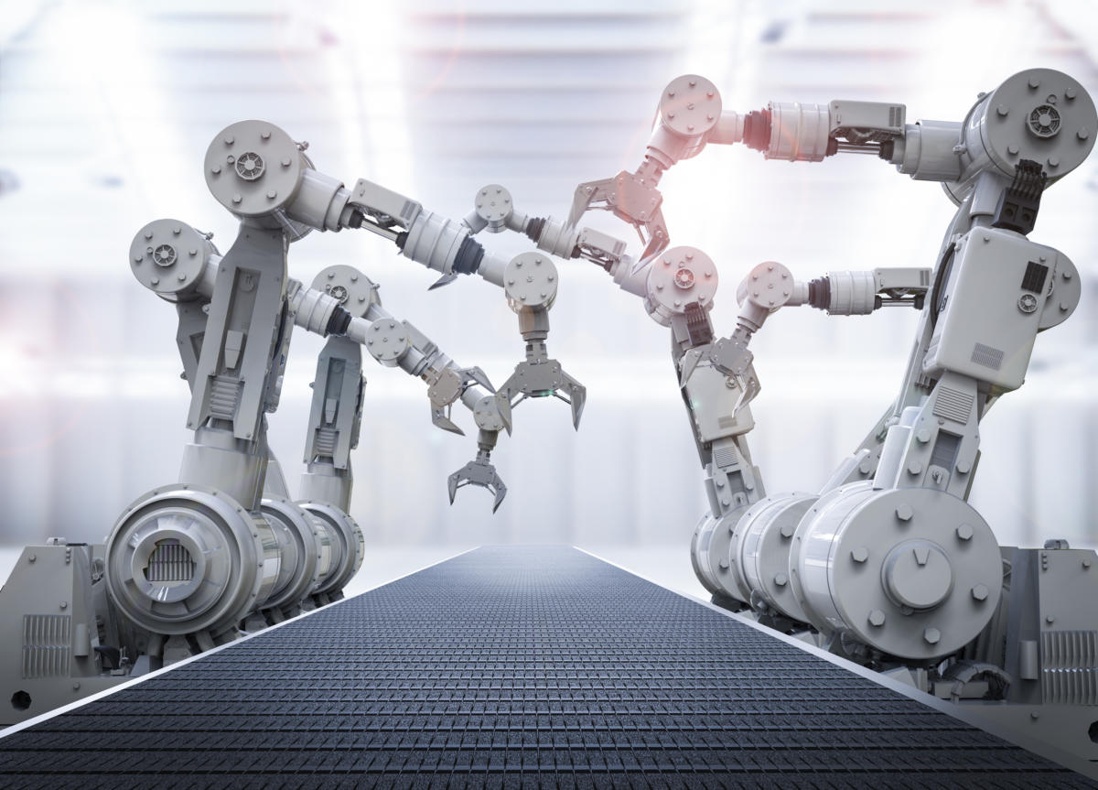

Figure: Industrial robots

# Automated Work Cell

In a business setting, a work cell is a rational and strategic allocation of resources. These structures are made to coordinate and enhance process flow, as well as to improve productivity, lower costs, and reduce waste.

Work cells are based on the lean production platform, which stresses value creation for the end user and waste reduction. Work cells are commonly used in industrial and workplace settings.

A work cell is usually set up to complete a certain task, and it is most often used in the manufacturing industry. It is a set of computers, humans, and other machinery used by businesses in the manufacturing process. These cells are commonly used to lower manufacturing costs while still increasing efficiency. Work cells are often used by several organizations to greatly minimize the rate of error (Kenton, 2021).

The equipment involved in the manufacturing process would be configured in a manufacturing plant so that the products manufactured shift quickly and seamlessly from one point to the next. This is only possible if the computers are arranged into work cells to allow for the logical progression of the products being manufactured—from raw materials to finished goods.

Offices and executive offices can also have work cells. Work cells may help with improved coordination and more effective use of mutual capital in this situation (Kenton, 2021).

Automation work cell means work cells for automated processes.

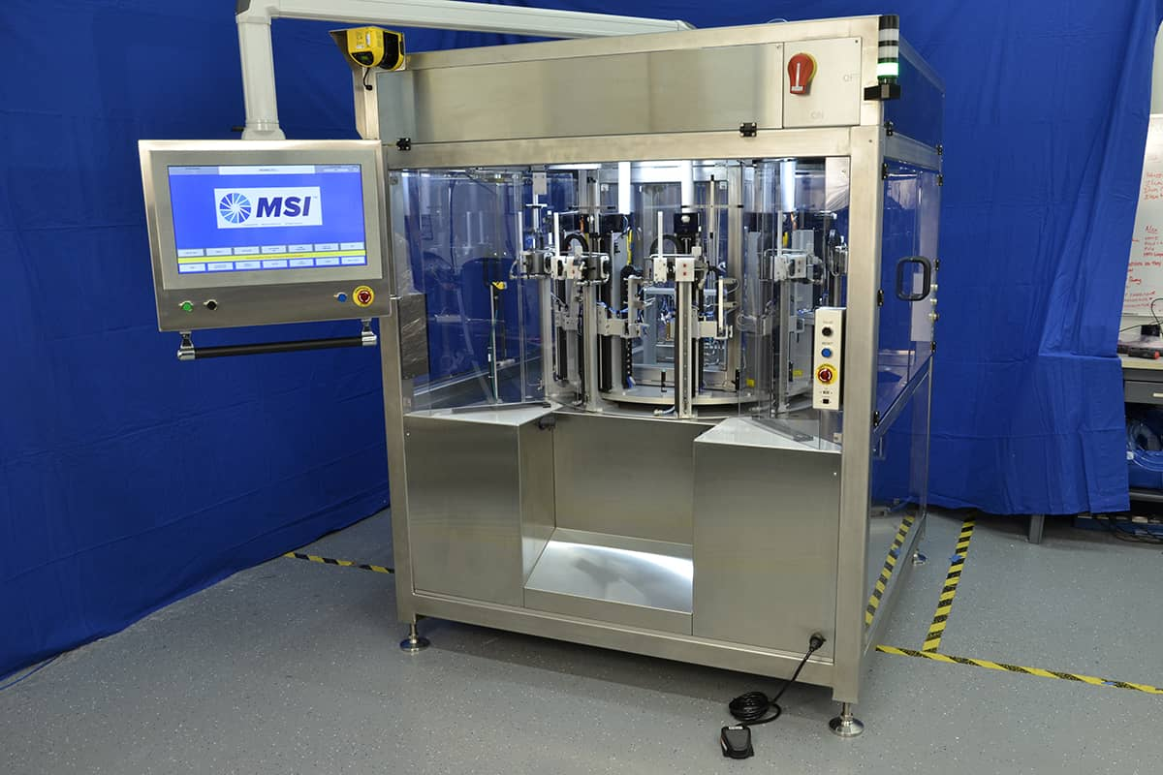

Figure: Example of Automated Work Cell

Computer- Integrated Manufacturing (CIM)

The use of computer-controlled machines and automation systems in the manufacture of products is referred to as computer-integrated manufacturing (CIM). CIM is a manufacturing process that incorporates various technologies such as computer-aided design (CAD) and computer-aided manufacturing (CAM) to provide an error-free manufacturing process that eliminates manual labour and automates routine activities. The CIM solution automates the production process by increasing the tempo of the process by using real-time sensors and closed-loop management processes. In the automobile, aircraft, space, and shipbuilding industries, it is commonly used (“Technopedia”, 2015).

CIM includes:

* Computer-aided design
* Prototype manufacture
* Determining the efficient method for manufacturing by calculating the costs and considering the production methods, volume of products, storage and distribution
* Ordering of the necessary materials needed for the manufacturing process
* Computer-aided manufacturing of the products with the help of computer numerical controllers
* Quality controls at each phase of the development.
* Product assembly with the help of robots
* Quality check and automated storage
* Automatic distribution of products from the storage areas to awaiting lorries/trucks
* Automatic updating of logs, financial data and bills in the computer system

The major components of CIM are as follows:

* Data storage, retrieval, manipulation and presentation mechanisms
* Real-time sensors for sensing the current state and for modifying processes
* Data processing algorithms

# References

1. “Built in”. (n.d.). What is robotics? Types of robots. Retrieved from <https://builtin.com/robotics>
2. Kenton, W. (2021, March 15). Behind work cells. Retrieved March 29, 2021, from <https://www.investopedia.com/terms/w/work-cell.asp>
3. Techopedia. (2015, August 16). What is Computer-Integrated Manufacturing (cim)?. Retrieved March 29, 2021, from <https://www.techopedia.com/definition/30965/computer-integrated-manufacturing-cim>